OGC Change Request

***Data Quality in Underground Facilities***

**Table of Contents**

1. Summary **1**

1.1. Background 1

1.2. Requirements 2

1.3. Scope 2

1.4. Document contributor contact points 2

1.5. What does this report mean for OGC in general 2

2. References **3**

3. Terms and definitions **4**

3.1. Accuracy 4

3.2. Consistency 4

3.3. Dataset 4

3.4. Integrated map of underground spaces 4

3.5. Quality 4

4. Abbreviated terms **5**

5. Overview **6**

6. Data quality in underground facilities **7**

6.1. Introduction 7

6.2. Data quality measures in underground facilities 8

[Appendix A: A work regulations for quality assessment of Integrated Map  
 of Underground Spaces in the Republic of Korea](#Appendix_A) **19**

Appendix B: Bibliography **20**

**1. Summary**

**1.1. Background**

The development and utilization of underground space are gradually increasing to address land shortages given the rapid urbanization driven by population growth and industrialization. For example, in Seoul, the Republic of Korea, various large-scale projects to efficiently use underground space are underway, such as the underground complex development project of Yeongdong Avenue in Samseong-dong, the underground space development project in the front park of Yongsan Station, and the Gangbuk underground city development project that connects the Seoul City Hall and Gwanghwamun Plaza. Although such underground space developments enable the efficient use of limited land space, there is a potential risk of disasters and damages such as sinkholes, ground subsidence, and destruction of underground facilities.

The computerization of underground facilities represents an early government effort to secure underground space safety by preventing human casualties due to accidents, such as the gas explosions that occurred in Ahyeon-dong (1994) and Daegu (1995). In the Republic of Korea, an underground facility computerization project has been conducted in urban areas from 1998 to 2010 and expanded to county areas in 2011. Thus, the government has mapped underground facilities over the past years.

Despite the underground facility computerization project, sinkholes occurred nationwide in 2014, and Internet search terms related to underground spaces, such as sinkholes, groundwater, sewers, and underground space flooding, reflected people’s concern sparked by these incidents. Accordingly, the government began to prepare preventive measures, and the Integrated Map of Underground Spaces has been constructed since 2015 by merging data from 15 types of underground facilities. Moreover, the government enacted the Special Act on Underground Safety Management in 2016, which came into force in 2018 and specifies measures to efficiently develop and safely manage underground space. Despite these efforts, there has been a growing demand for improving the quality of underground space information, as other accidents have occurred in underground spaces, such as the rupture of a hot water pipe in Goyang, the fire on cable tunnels in Ahyeon-dong, and the ground subsidence in Sangdo-dong (Seoul) and Guri (Gyeonggi-do).

Considering this background, we aim to prepare measures to improve the quality inspection standards and methods as specified in the Regulations on Producing Integrated Map of Underground Spaces devised by the Ministry of Land, Infrastructure and Transport of the Republic of Korea for a high-quality Integrated Map of Underground Spaces. Specifically, we propose measures to improve the quality assurance of pipeline-type underground facilities, the so-called life lines given their importance for citizen’s daily activities and their highest risk of accident among the 15 types of underground facilities.

**1.2. Requirements**

This report is neutral information domain, i.e., it specifies data quality for the Integrated Map of Underground Spaces, also that can be applied to all underground space information domains: smart city, facilities safety, ground collapse, road excavation, etc.

**1.3. Scope**

This report proposes data quality for the Integrated Map of Underground Spaces in the Republic of Korea. It defines specifications such as how to measure the quality criteria of the underground data. This report is closely related to the interface of the data quality part of OGC’s MUDDI standard. The report was developed for the following concepts:

* Introduction of the Integrated Map of Underground Spaces
* Definition of data quality standards and specifications for the Integrated Map of Underground Spaces
* Design a data model of data quality using UML

**1.4. Document contributor contact points**

All questions regarding this document should be directed to the editor or the contributors:

|  |  |  |
| --- | --- | --- |
| Name | Position | Organization |
| Sangkeun Bae | Principal researcher | LX SIRI (Korea Land and Geospatial Informatix corp. Spatial Information Research Institute) |
| Sangmin Kim | Senior researcher |
| Eunjin Yoo | Senior researcher |
| Keobae Lim | Senior researcher |
| Dawoon Jeong | Senior researcher |

**1.5. What does this report mean for OGC in general**

OGC MUDDI(v1.1) SWG and Data Quality DWG should be interested in this report for different reasons. For the MUDDI SWG, it suggests ways to supplement/improve MUDDI’s interface of data quality. For the Data Quality DWG, it provides data quality in terms of the underground space domain.

**2. References**

The following normative documents are referenced in this document:

* ISO 19107:2019, Geographic Information – Spatial schema
* ISO 19109:2015, Geographic Information – Rules for application schema
* ISO 19115-1:2014, Geographic Information – Metadata – Part 1 : Fundamentals
* ISO 19131:2007, Geographic Information – Data product specifications
* ISO 19157:2013, Geographic Information – Data quality
* ISO/TS 19115-3:2016, Geographic Information – Metadata – Part 3 : XML schema implementation for fundamental concepts
* OGC 16-050, OGC® Imagery quality and accuracy ER
* OGC 16-064r1, OGC® CityGML quality interoperability experiment
* OGC 17-018, OGC® Testbed-13 Data quality specification engineering report
* OGC 17-032, OGC® Testbed-13 Abstract Data Quality ER
* OGC 19-081, MUDDI v1.1 (Model for underground data definition and integration) engineering report
* QualityML v1.0, Quality indicators dictionary and markup language

**3. Terms and definitions**

**3.1. Accuracy**

* Closeness of agreement between a test result or measurement result and the true value.  
  [Source: ISO 3534-2:2006, 3.3.1]

**3.2. Consistency**

* The degree to which data has attributes that are free from contradiction and coherent with other data in a specific context of use. It can be either or both among data regarding one entity and across similar data for comparable entities.  
  [Source: ISO 25000 Standards – ISO 25012, Consistency]

**3.3. Dataset**

* Identifiable collection of data. [Source: ISO 19115-1:2014, 4.3]

**3.4. Integrated map of underground spaces**

* It means a map that has integrated underground information necessary to develop, use, and manage the underground.  
  [Source: ‘Special Act on Underground Safety Management’ in the Republic of Korea]

**3.5. Quality**

* Degree to which a set of inherent characteristics fulfills requirements.  
  [Source: ISO 9000:2015, 3.6.2]

**4. Abbreviated terms**

* ASCE: American Society of Civil Engineers
* DWG: Domain Working Group
* DQ: Data Quality
* ER: Engineering Report
* ISO: International Organization for Standardization
* LX: Korea Land and Geospatial Informatix corp.
* MUDDI: Model for Underground Data Definition and Integration
* OGC: Open Geospatial Consortium
* QualityML: Quality Indicators Dictionary and Markup Language
* SIRI : Spatial Information Research Institute
* SUE: Subsurface Utility Engineering
* SWG: Standards Working Group
* UML: Unified Modeling Language

**5. Overview**

Data quality is defined as the “degree to which a set of data continuously meet users’ requirements and satisfaction.” Hence, data quality management can be defined as “a series of activities performed to increase user satisfaction by continuously maintaining and improving the data quality.” Spatial data are attracting attention for obtaining spatial characteristics and as a basis for integration with information from other domains. With the implementation of data linkage and sharing, data quality has become more relevant, and the importance of data reliability has been widely recognized. Thus, the government in the Republic of Korea, devotes continued efforts to both enact applicable laws and regulations and achieve data standardization.

Underground space is a concept symmetrical to aboveground space and refers to a facility built below the surface of a natural environment for commercial or public use. From this concept, the Integrated Map of Underground Spaces can be defined as “spatial data including positional information on artificial and natural objects in underground spaces and information for spatial recognition.” Although the criteria and methods for quality inspection of such integrated maps have been set out as work regulations, various aspects have ambiguous or abstract definitions and explanations regarding quality management evaluation criteria and methods, which mostly rely on visual assessment.

A regulations in the Republic of Korea on spatial data quality management comprise the quality standards specified in 3D National Geospatial Information Generation Regulations (National Geographic Information Institute), Detailed Regulations on the Operation of the National Geospatial Information Center, and Work Regulations on the Generation of Interior Geospatial Information (Ministry of Land, Infrastructure and Transport).

These quality standards were established in line with standard ISO 19157, with the detailed evaluation items and inspection method of each element being modified to suit the evaluated data. We compare and analyze the 3D National Geospatial Information Generation Regulations, Underground Map Production Regulations, and ISO 19157, which have similar data characteristics to those of the Integrated Map of Underground Spaces.

As this map is generated from 3D spatial data, it presents a similar quality to that of 3D national geospatial information. Thus, the 3D data quality can be assessed considering topological consistency and position accuracy related to the data structure and positional/adjacent accuracy. Unlike 3D national geospatial information, the Integrated Map of Underground Spaces does not cover image data, and thus the accuracy of grid data is not considered.

**6. Data quality in Underground facilities**

**6.1. Introduction**

This standard deals with the quality standards of underground data related to the Integrated Map of Underground Spaces in the Republic of Korea. Based on these quality standards defined by our research team, it is expected that it can be applied to the Interface of Data Quality related to MUDDI currently being developed by OGC.

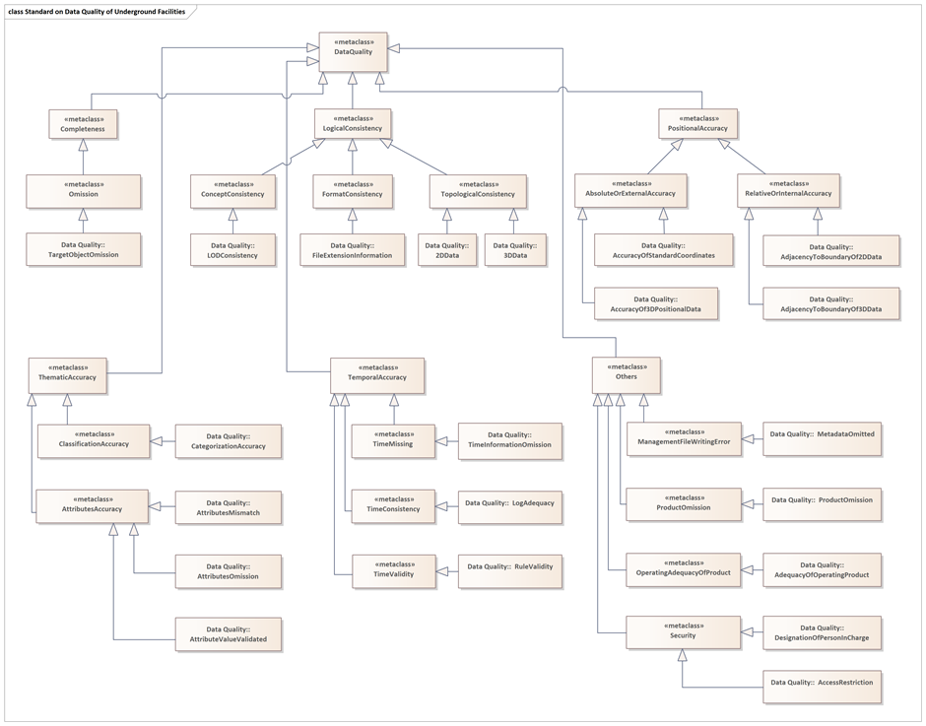Regarding the Republic of Korea's Integrated Map of Underground Spaces, there are existing quality inspection standards stipulated in draft format, but this is not much different from the content of ISO 19157. In addition, there are many issues in inspecting various types of underground data based on the inspection standards. Therefore, it is expected that the Korean system will be revised in the future based on this standard, and it is expected that the quality of underground data can be inspected more accurately. In addition, in Korea, an individual directly inspects the quality of underground data using the visual inspection method, and in terms of developing it in an automated form, the effect of this standard is expected to be very influential.

Figure 1. UML diagram of data quality in the Integrated Map of Undergroud Spaces

**6.2. Data quality measures in underground facilities**

As previously stated, current quality inspection methods can be notably improved to ensure the accuracy and reliability of information on the various types of underground facilities included in the Integrated Map of Underground Spaces in the Republic of Korea. Hence, we aim to present measures to improve quality inspection of the Integrated Map of Underground Spaces.

We add three quality inspection items, namely, methods, rules, and flow diagram, to the existing four quality inspection items, namely, quality elements, sub-elements, detailed sub-elements, and quality inspection standards. The quality inspection methods define more specifically the items that should be checked during data inspection based on the standard items.

The quality inspection rules provide an overview of the items necessary for software-based automated quality inspection. Specifically, we detail the rules and algorithms to check the topological consistency and positional accuracy of graphic data by analyzing the existing data that define the geometrical structure and topological relations of spatial data. Such details allow to inspect not only attribute information but also graphic information by using software. The topological consistency checks the overlap, crossing, and superimposition of graphics to confirm the spatial topology and geometrical adequacy of the 2D and 3D data. The positional accuracy checks the compliance of the coordinate system, 3D and 2D data overlap, adequacy of the priority order of depth application, and adjacency fit between features to confirm the absolute and relative data positional accuracy.

**6.2.1. Completeness**

The completeness includes quality inspection criteria related to omission.

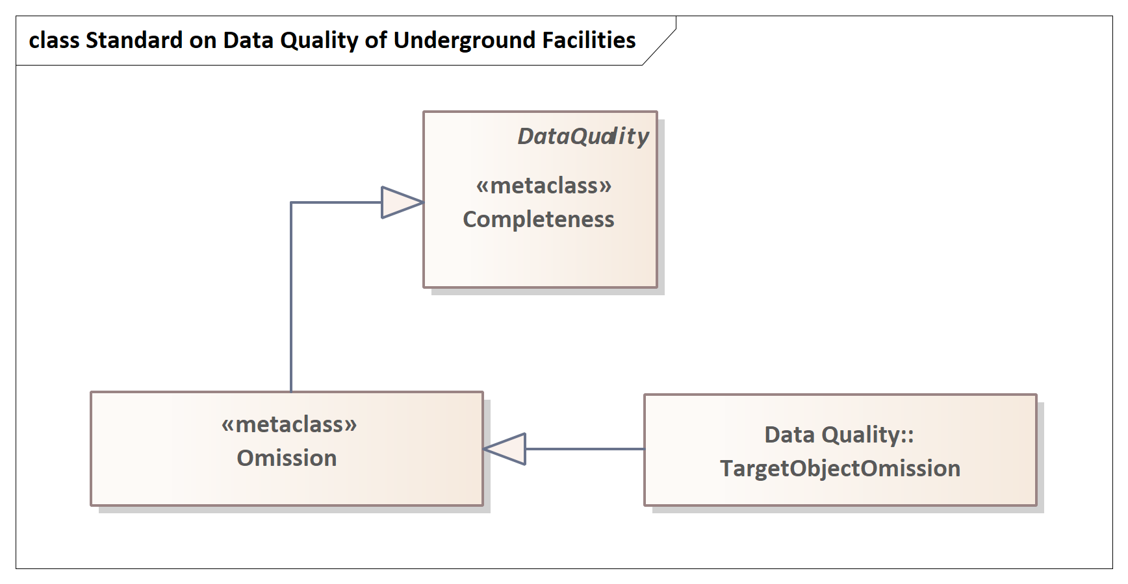`

Figure 2. UML diagram of data quality (Completeness)

|  |  |
| --- | --- |
| **Model element** | **Contents** |
| Quality category | Omission |
| Sub elements | Target object omission |
| Standard for quality assessment | Comparison of list and quantity of raw data and final product |
| Quality Assessment Method and Rule | Matching the number of raw data with the number of files on final product |
| Quality scope | Integrated map of underground spaces |

**6.2.2. Logical consistency (Standard)**

The logical Completeness includes quality inspection criteria related to concept consistency, format consistency, topological consistency.

Figure 3. UML diagram of data quality (Logical consistency)

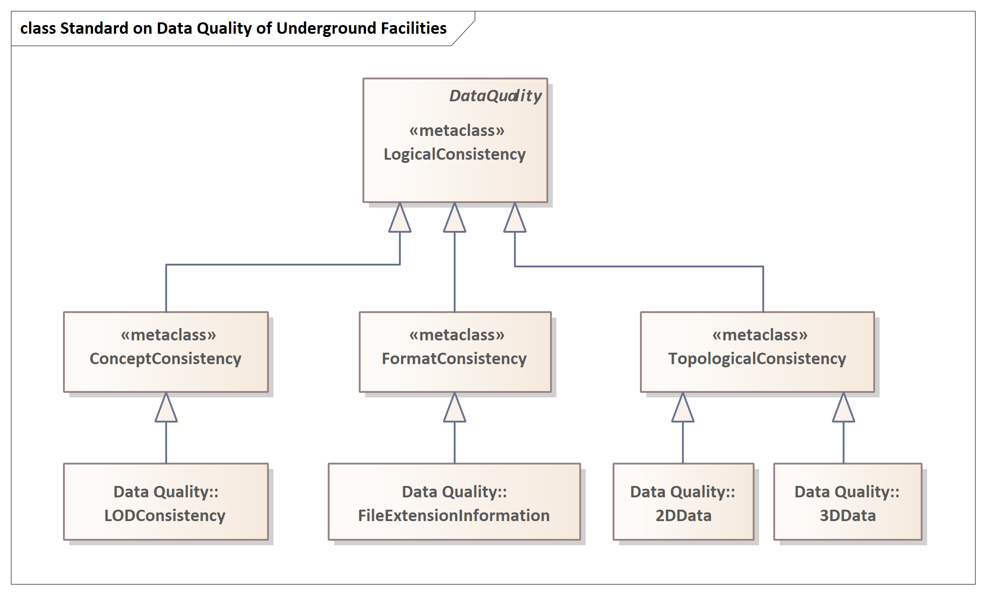

|  |  |
| --- | --- |
| **Model element** | **Contents** |
| Quality category | Concept consistency |
| Sub elements | LOD consistency |
| Standard for quality assessment | Confirmation of compliance with LOD production standard for underground facilities |
| Quality assessment method and rule | Visual inspection of adequacy of application of LOD production standards |
| Quality scope | Integrated map of underground spaces |

|  |  |
| --- | --- |
| **Model element** | **Contents** |
| Quality category | Format consistency |
| Sub elements | File extension information |
| Standard for quality assessment | Confirmation of data stored in accordance with physical structure |
| Quality assessment method and rule | Checking adequacy of file extension |
| Quality scope | Integrated map of underground spaces |

|  |  |
| --- | --- |
| **Model element** | **Contents** |
| Quality category | Topological consistency |
| Sub elements | 2D Data |
| Standard for quality assessment | Confirmation of adequacy of topological condition for 2D data |
| Quality assessment method and rule | Checking the spatial topology and adequacy of geometrical design of 2D data  Rule 1: <Preprocessing (Confirmation of data integrity>  1. Extract duplicate objects,  2. Check the connectivity after extracting distant polylines  2-1. If there is connectivity (extracting unconnected polylines despite the same ID they have)  2-2. If there is no connectivity (extracting polylines not connected to other objects)  Rule 2: <Checking interior points in a single pipe line>  1. Extract points with point-to-point plane distance less than the threshold of 20m  Rule 3: <Checking start and end points of pipe line>  1. Check the connection of start and end of the target pipe line to other lines, manhole and valve |
| Quality scope | Integrated map of underground spaces |

|  |  |
| --- | --- |
| **Model element** | **Contents** |
| Quality category | Topological consistency |
| Sub elements | 3D Data |
| Standard for quality assessment | Confirmation of adequacy of topological condition for 3D data |
| Quality assessment method and rule | Checking adequacy of geometry (ie. intersection and overlap and topology of 3D data  Rule 1: <Confirmation of intersection and overlapping>  1. Extract intersection points between pipe lines  2. Check z-value and diameter of overlapping points between pipe lines  3-1. Error occurred if z-values between pipe lines are the same  3-2. Check diameter for overlapping if z-values between pipe lines are different  Rule 2: <Visual Inspection>  Check intersection and overlapping after extracting partial sample of 3D model |
| Quality scope | Integrated map of underground spaces |

**6.2.3. Positional accuracy (Spatial)**

The positional accuracy includes quality inspection criteria related to absolute or external accuracy, relative or internal accuracy.

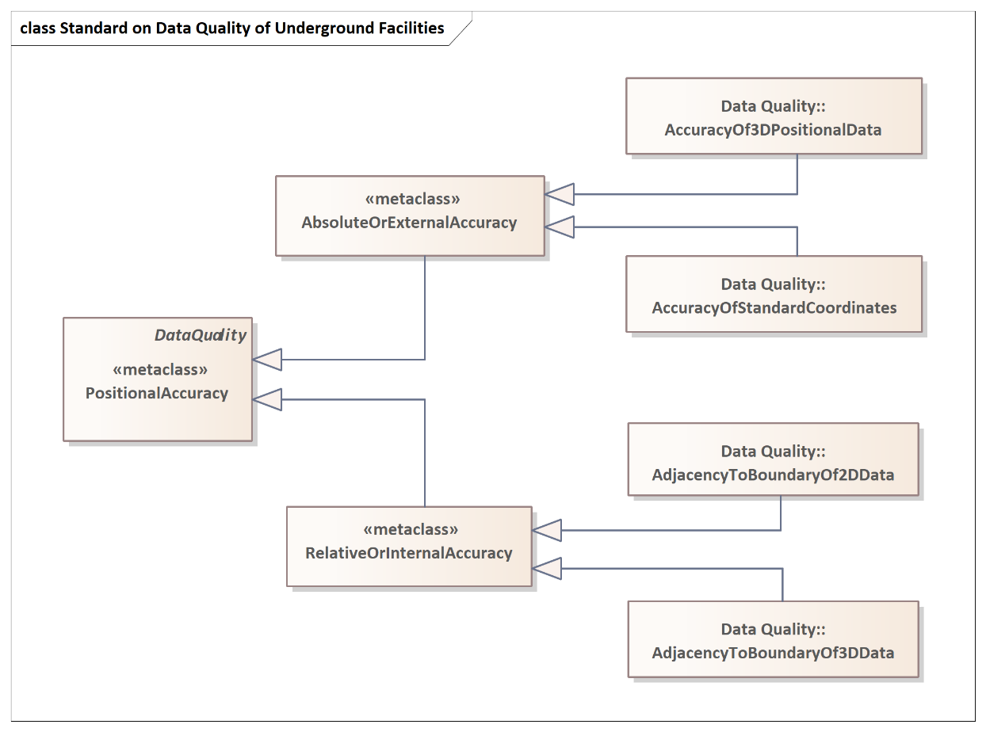

Figure 4. UML diagram of data quality (Positional accuracy)

|  |  |
| --- | --- |
| **Model element** | **Contents** |
| Quality category | Absolute or external accuracy |
| Sub elements | Accuracy of standard coordinates |
| Standard for quality assessment | Confirmation of application of international geodetic reference system (rectangular coordinate) |
| Quality assessment method and rule | Checking feature information of PRJ files, the coordinate system setup file of SHPFile (GRS_1980)  Checking presence of object with central GRS80 TM exceeding the range of 200,000 and 600,000  Rule:  Checking whether the extracted MBR (Minimum Bounding Rectangle) is located within X=600,000 and Y=200,000 |
| Quality scope | Integrated map of underground spaces |

|  |  |
| --- | --- |
| **Model element** | **Contents** |
| Quality category | Absolute or external accuracy |
| Sub elements | Accuracy of 3D positional data (1) |
| Standard for quality assessment | Confirmation of positional accuracy of 3D model by overlapping 2D data |
| Quality assessment method and rule | Checking positioning adequacy by overlap with raw dat after the invertion of 3D model to 2D  Rule:  1. Invertion of 3D model to 2D  2. Overlap with raw data  3-1 pipe line: checking central positioning of pipe line (polygon) inversed from pipe line (polyline) of raw data  3-2. Manhole and valve: checking inclusion or adjacency of manhole and valve (point) in raw data to inversed manhole and valve (polygon) |
| Quality scope | Integrated map of underground spaces |

|  |  |
| --- | --- |
| **Model element** | **Contents** |
| Quality category | Absolute or external accuracy |
| Sub elements | Accuracy of 3D positional data (2) |
| Standard for quality assessment | Adequacy confirmation reflecting rules applicable to depth of pipe lines |
| Quality assessment method and rule | Checking the adequacy of applying the priority of depth of pipe lines (point, pipe lines (adjacent/average))  Rule:  1. Checking the presence of points within point-to-point distance of 20cm  2-1. Checking whether the depth values of two points match if points exist  2-1-1. Matching value: Pass  2-1-2. Unmatching value: Error (confirmation of raw data required)  ※ It is not an error if two points in raw data have depth values while it is an error if only one has the value  2-2. Checking whether a point shares two lines in case of no point indicated  2-2-1. If yes, check reflection of average depth value of pipe line of two lines as depth value  2-2-1-1. use of average value: Pass  2-2-1-2. No reflection of average value: Error  2-2-2. If not, check reflection of the depth of appropriate line as depth value  2-2-2-1. Reflection of depth value: Pass  2-2-2-2. No reflection of depth value: Error |
| Quality scope | Integrated map of underground spaces |

|  |  |
| --- | --- |
| **Model element** | **Contents** |
| Quality category | Absolute or external accuracy |
| Sub elements | Accuracy of 3D positional data (3) |
| Standard for quality assessment | Confirmation reflecting rules applicable to depth of manhole and valve |
| Quality assessment method and rule | Checking the adequacy of applying the priority of depth of manhole and valve  Rule:  1. Checking the presence of point within the manhole or valve radius of 20cm  2-1. If yes, check depth attributes of pipe line with the point  2-1-1. When the depth attribute is a depth, pipe line (adjacent) depth: depth value +(pipe diameter) + (extra depth)  2-1-2. When the depth attribute is average depth: : Depth value + (Extra depth)  ※ Values in bracket (pipe diameter, extra depth) are only applicable to manhole  2-2. No point: Average depth applied |
| Quality scope | Integrated map of underground spaces |

|  |  |
| --- | --- |
| **Model element** | **Contents** |
| Quality category | Relative or internal accuracy |
| Sub elements | Adjacency to boundary of 2D data |
| Standard for quality assessment | Confirmation of consistent adjacency and separation between 2D pipe lines, pipe line and manhole, and pipe line and valve |
| Quality assessment method and rule | Checking presence of manhole and valve (points) distant from pipe line (between pipe line and manhole/valve)  Rule:  1. Checking for intersection of valves and manholes (points) and pipelines (polylines)  2. It is an error if the shortest distance between valve/manhole and pipe line is greater than threshold of 20cm |
| Quality scope | Integrated map of underground spaces |

|  |  |
| --- | --- |
| **Model element** | **Contents** |
| Quality category | Relative or internal accuracy |
| Sub elements | Adjacency to boundary of 3D data |
| Standard for quality assessment | Confirmation of consistent adjacency and spacing between 3D pipe lines, pipe line and manhole, and pipe line and valve |
| Quality assessment method and rule | Checking the presence of manholes and valves distant from the pipeline  Rule: <Visual Inspection>  Checking the gap (or distance) in partial samples extracted from 3D model |
| Quality scope | Integrated map of underground spaces |

**6.2.4. Thematic accuracy (Attributes)**

The thematic accuracy includes quality inspection criteria related to classification, attributes accuracy.

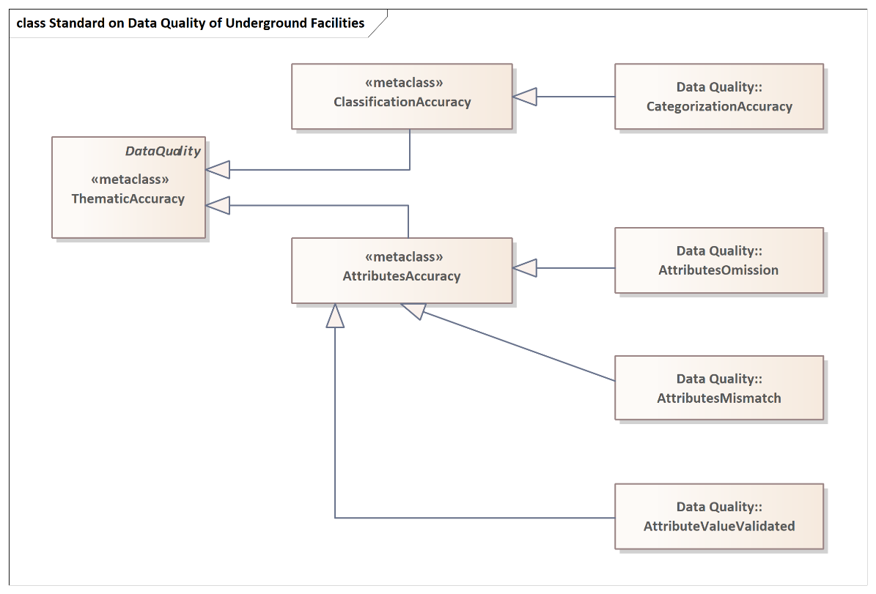

Figure 5. UML diagram of data quality (Thematic accuracy)

|  |  |
| --- | --- |
| **Model element** | **Contents** |
| Quality category | Classification accuracy |
| Sub elements | Categorization accuracy (1) |
| Standard for quality assessment | Confirmation of conformity and compliance between standard data item and final product |
| Quality assessment method and rule | Checking whether the categories of final product are matched with those of standard data |
| Quality scope | Integrated map of underground spaces |

|  |  |
| --- | --- |
| **Model element** | **Contents** |
| Quality category | Classification accuracy |
| Sub elements | Categorization accuracy (2) |
| Standard for quality assessment | Confirmation of application of final product to table design |
| Quality assessment method and rule | Checking whether the final product attribute table is matched with table definition indicated in the rule |
| Quality scope | Integrated map of underground spaces |

|  |  |
| --- | --- |
| **Model element** | **Contents** |
| Quality category | Attributes accuracy |
| Sub elements | Attributes mismatch |
| Standard for quality assessment | Confirmation of matching attributes between raw data (.shp) and final product |
| Quality assessment method and rule | Checking whether attribute field, number, and value of raw data are matched with those of final product |
| Quality scope | Integrated map of underground spaces |

|  |  |
| --- | --- |
| **Model element** | **Contents** |
| Quality category | Classification accuracy |
| Sub elements | Attributes omission |
| Standard for quality assessment | Confirmation of key information including attribute information omitted |
| Quality assessment method and rule | - |
| Quality scope | Integrated map of underground spaces |

|  |  |
| --- | --- |
| **Model element** | **Contents** |
| Quality category | Classification accuracy |
| Sub elements | Attribute value validated |
| Standard for quality assessment | Confirmation of logical validity of value of attributes in domain |
| Quality assessment method and rule | Checking validity of attributes value format, structure, and range |
| Quality scope | Integrated map of underground spaces |

**6.2.5. Temporal accuracy (Log)**

The temporal accuracy includes quality inspection criteria related to time missing, time consistency, time validity.

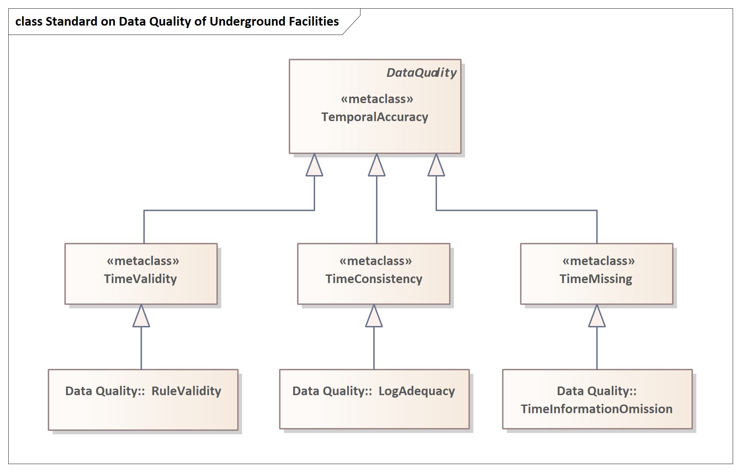

Figure 6. UML diagram of data quality (Temporal accuracy)

|  |  |
| --- | --- |
| **Model element** | **Contents** |
| Quality category | Time missing |
| Sub elements | Time information omission |
| Standard for quality assessment | Confirmation of no omission of information generation, edition, and deletion time |
| Quality assessment method and rule | Checking whether time information is omitted for each event (generation, modification, and deletion) within the log (data history file) |
| Quality scope | Integrated map of underground spaces |

|  |  |
| --- | --- |
| **Model element** | **Contents** |
| Quality category | Time consistency |
| Sub elements | Log adequacy |
| Standard for quality assessment | Confirmation of accumulated logs appropriate for order of generation, modification and deletion of information |
| Quality assessment method and rule | Checking adequacy of history according to the time order of rules defined within logs (history file) |
| Quality scope | Integrated map of underground spaces |

|  |  |
| --- | --- |
| **Model element** | **Contents** |
| Quality category | Time validity |
| Sub elements | Rule validity |
| Standard for quality assessment | Confirmation of the adequate time-recording-method within log |
| Quality assessment method and rule | Checking whether the time in log is recorded in the form of ‘YYYY-MM-DD’ in accordance with ISO 8601 |
| Quality scope | Integrated map of underground spaces |

**6.2.6. Others**

The others include quality inspection criteria related to management file writing error, product omission, operating adequacy of product, security.

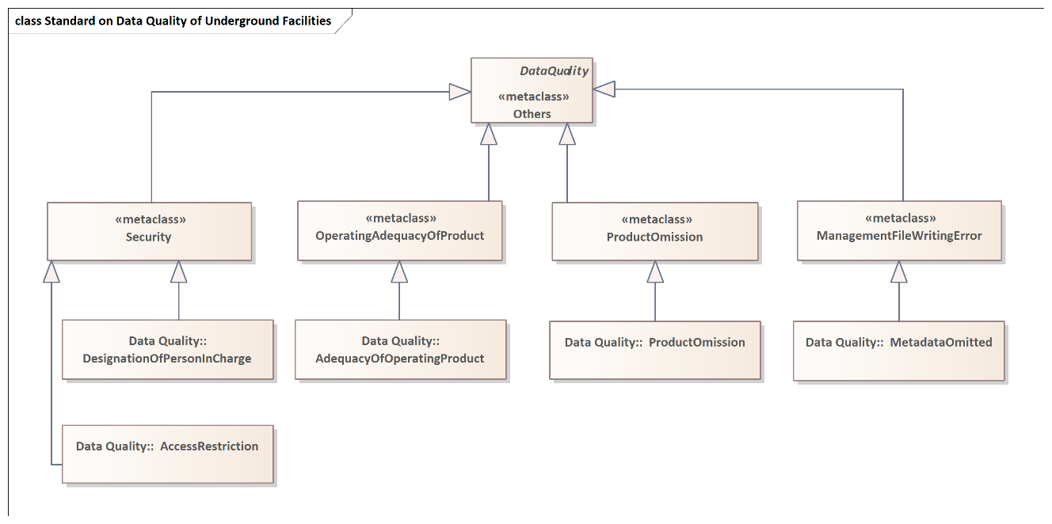

Figure 7. UML diagram of data quality (Others)

|  |  |
| --- | --- |
| **Model element** | **Contents** |
| Quality category | Management file writing error |
| Sub elements | Metadata omitted |
| Standard for quality assessment | Confirmation of constructing metadata per layer in compliance with metadata standard |
| Quality assessment method and rule | Checking the present of metadata file |
| Quality scope | Integrated map of underground spaces |
| **Model element** | **Contents** |
| Quality category | Product omission |
| Sub elements | Product omission |
| Standard for quality assessment | Confirmation of final product such as index, raw data and 3DS omitted |
| Quality assessment method and rule | Comparing with work rule to check omission in the product list |
| Quality scope | Integrated map of underground spaces |

|  |  |
| --- | --- |
| **Model element** | **Contents** |
| Quality category | Operating adequacy of product |
| Sub elements | Adequacy of operating product |
| Standard for quality assessment | Confirmation of adequacy of attribute information and 3D model for uploading operation server |
| Quality assessment method and rule | Checking error in case of server upload |
| Quality scope | Integrated map of underground spaces |

|  |  |
| --- | --- |
| **Model element** | **Contents** |
| Quality category | Security |
| Sub elements | Designation of person in charge |
| Standard for quality assessment | Confirmation of designation of a person to be in charge of data management |
| Quality assessment method and rule | Checking designation of person for each manageable data and stipulation |
| Quality scope | Integrated map of underground spaces |

|  |  |
| --- | --- |
| **Model element** | **Contents** |
| Quality category | Security |
| Sub elements | Access restriction |
| Standard for quality assessment | Confirmation of setup of data security level |
| Quality assessment method and rule | Checking the presence and adequacy of data security level for metadata |
| Quality scope | Integrated map of underground spaces |

**Appendix A: A work regulations for quality assessment of Integrated Map of Underground Spaces in the Republic of Korea**

|  |  |  |  |  |
| --- | --- | --- | --- | --- |
| **Quality Elements** | **Sub-Elements** | **Sub-sub Elements** | **Standard for Quality Assessment** | **Methods and Targets** |
| **Underground Facility (pipe Line)** |
| Completeness | Omission | Target Object  Omission | Checking an object omitted in the standard data category | Indoor Inspection  (1% of the Sample) |
| Logical  Consistency  (Standard) | Concept  Consistency | LOD  (Visualization)  Consistency | Checking conformity with LOD (Visualization) Production Standard | Indoor Inspection  (1% of the Sample) |
| Topological  Consistency | 2D Data  Consistency | Checking 2D (Data) topological condition |
| 3D Data  Consistency | Checking 3D (Data) topological condition |
| Positional  Accuracy  (Spatial) | Absolute  or  External Accuracy | Accuracy of Standard  Coordinates | Checking application of standard coordinates | Indoor Inspection  (1% of the Sample) |
| Accuracy of 2D  Positioning Data | Positional accuracy of 2D data |
| Accuracy of 3D  Positioning Data | Positional accuracy of 3D data | Indoor Inspection  (1% of the Sample) |
| Relative  or  Internal Accuracy | Adjacency to Boundary of 2D Data | Checking accuracy of boundary adjacency to 2D data | Indoor Inspection  (1% of the Sample) |
| Adjacency to Boundary of 3D Data | Checking accuracy of boundary adjacency to 3D data |
| Thematic  Accuracy  (Attributes) | Classification  Accuracy | Category  Accuracy | Checking accuracy of standard data categorization | Indoor Inspection  (1% of the Sample) |
| Logical  Accuracy | Logical Accuracy | Checking for application of structure table design |
| Attributes  Accuracy | Attributes Unmatched | Checking for unmatching attributes |
| Attributes Omitted | Checking for omitted attributes |
| Others | Errors in Writing Management File | Metadata Omitted | Checking for errors (Y/N) or creation of Metadata | Indoor (Total) Inspection |
| product Omitted | Product Omitted | Checking for final product omitted (Y/N) |
| Operating Adequacy of product | Operating Adequacy of product | Checking adequacy of operating final product in system environment |

**Appendix B:** **Bibliography**

[1] Sangkeun Bae·Sangmin Kim·Eunjin Yoo, 2020, Research on Improving Quality Management for Underground Space Integration Map - Focusing on pipe-type underground facilities, Journal of Cadastre & Land InformatiX, Vol. 50, No. 2, pp. 221-235, https://doi.org/10.22640/lxsiri.2020.50.2.221

[2] ISO 19107:2019, Geographic Information – Spatial schema

[3] ISO 19109:2015, Geographic Information – Rules for application schema

[4] ISO 19115-1:2014, Geographic Information – Metadata – Part 1 : Fundamentals

[5] ISO 19131:2007, Geographic Information – Data product specifications

[6] ISO 19157:2013, Geographic Information – Data quality

[7] ISO/TS 19115-3:2016, Geographic Information – Metadata – Part 3 : XML schema implementation for fundamental concepts

[8] OGC 16-050, OGC® Imagery quality and accuracy ER

[9] OGC 16-064r1, OGC® CityGML quality interoperability experiment

[10] OGC 17-018, OGC® Testbed-13 Data quality specification engineering report

[11] OGC 17-032, OGC® Testbed-13 Abstract Data Quality ER

[12] OGC 19-081, MUDDI v1.1 (Model for underground data definition and integration) engineering report

[13] QualityML v1.0, Quality indicators dictionary and markup language